28.10: a) At 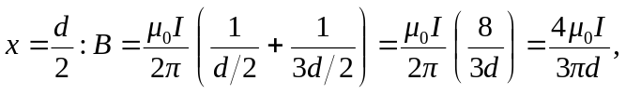 in the direction.
b) The position 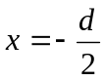 is symmetrical with that of part (a), so the magnetic field there is 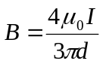, in the direction.

